Name: Sakshi Mohan Kamble PRN: 2020BTEIT00205

Course: Agile Software Tools and Practices

# Title:

To use selenium for web testing

# Steps:

1. **Install Selenium using Docker Hub:**

Docker Hub: <https://hub.docker.com/r/selenium/standalone-chrome>

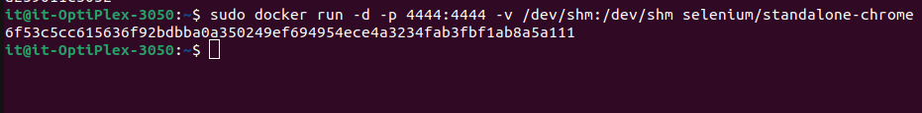Running the docker image for Selenium:

Installing selenium:

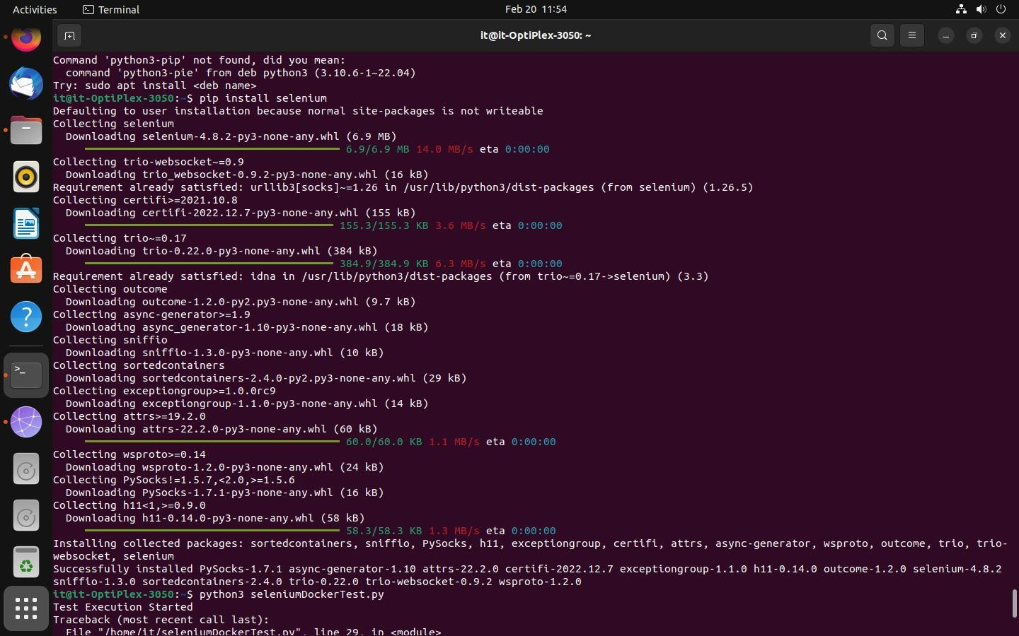

1. **Start a Demo Web Application from Docker:**

Pull the Docker Image:

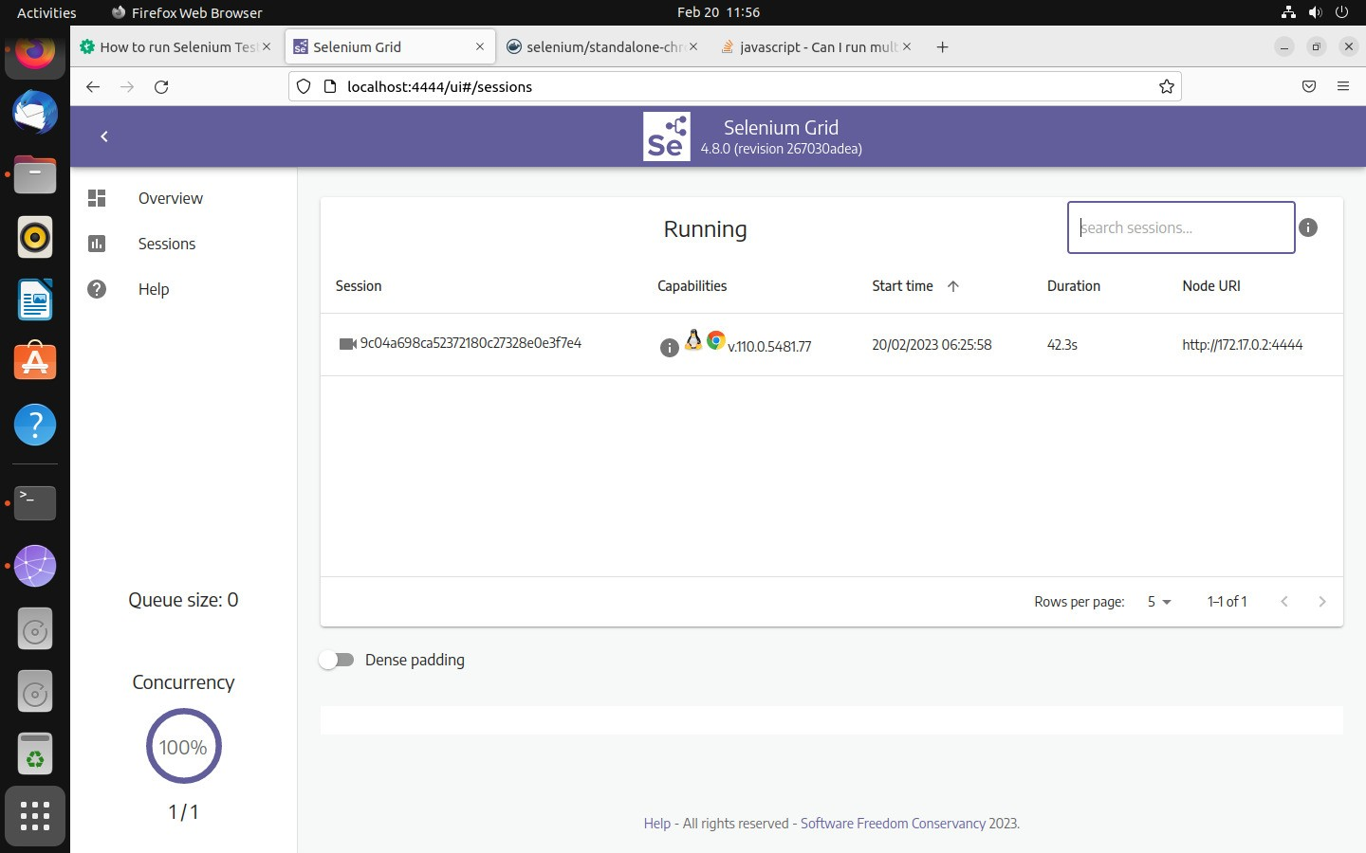

Run the Application on Local Host:

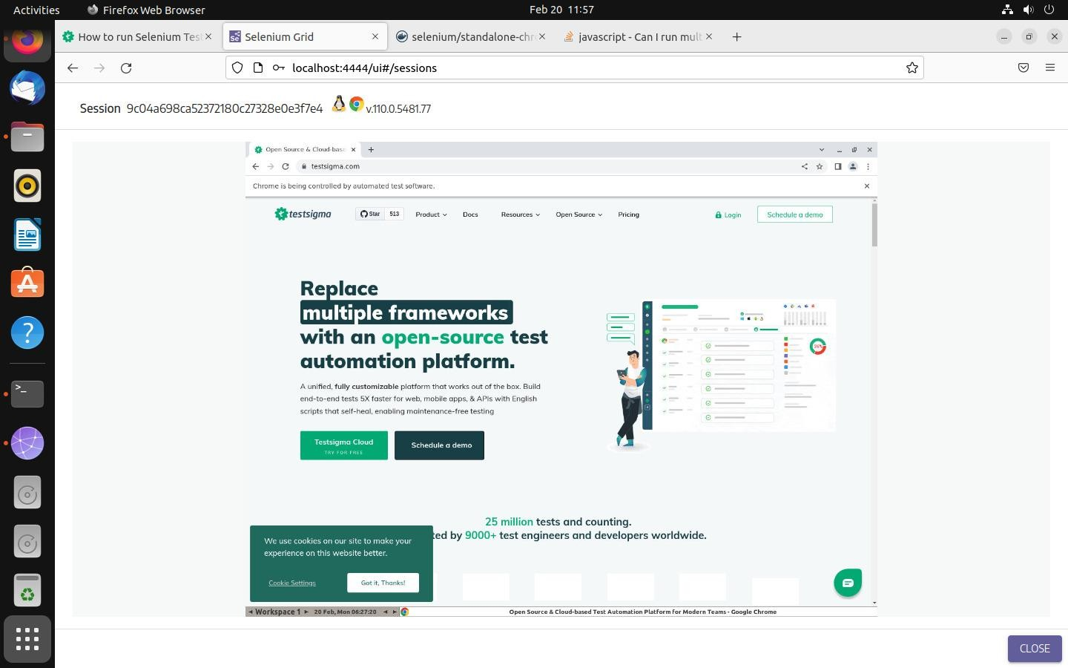

1. **Python Script to start Selenium Session:**

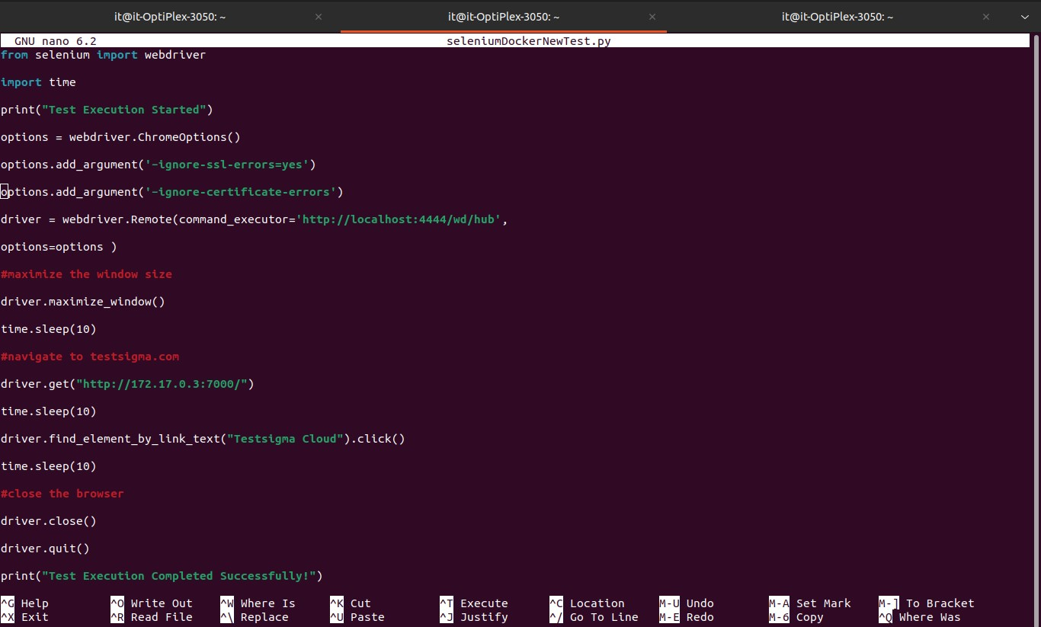

In driver.get(“http://172.17.0.3:7000/”) we have used the endpoint of the web application.

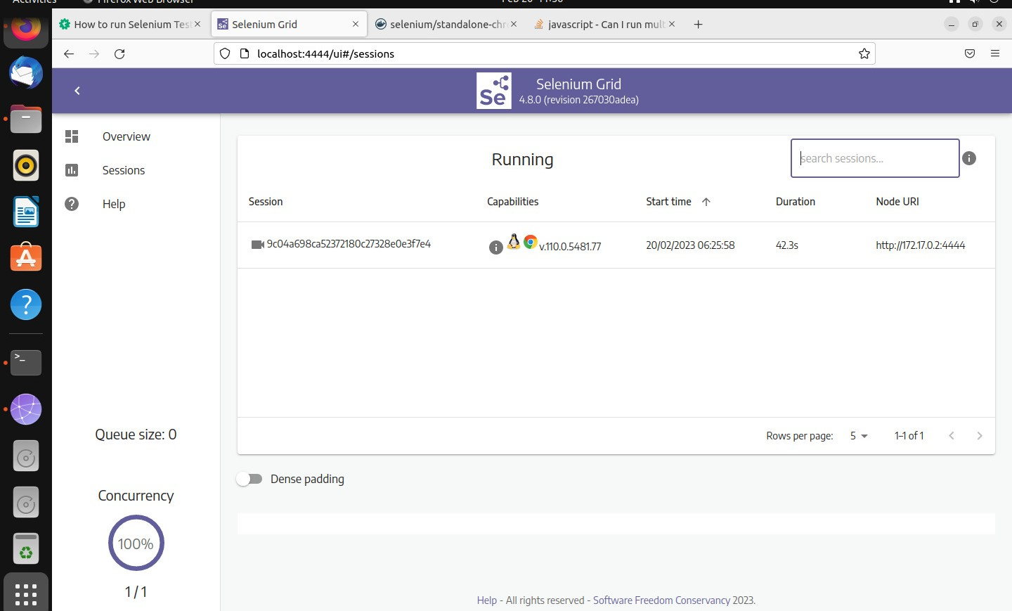You can view the session in the sessions Tab:

1. **Connect to the Session:**

The Default password to connect to the session is “secret**”**

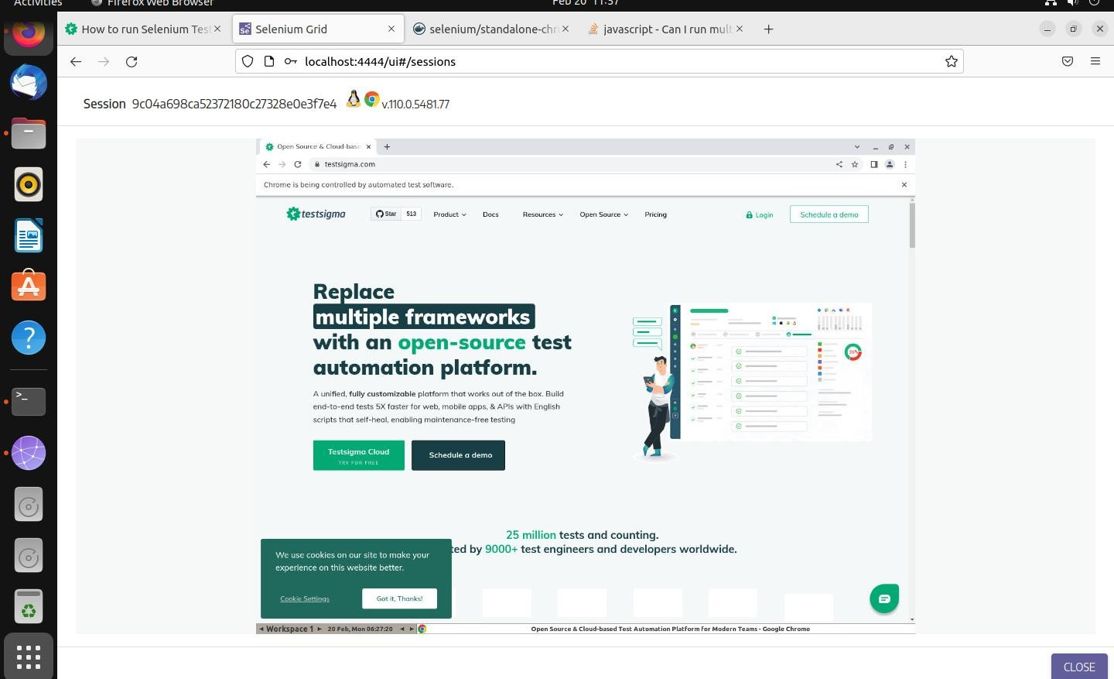This connects you to the session and you can test your web Application

# Conclusion:

Selenium is a useful test automation tool to test Web applications.